Project 6 – Milestone Screenshots

Table of Contents
WSL (Windows Subsystem for Linux) Installed 1
First Container running successfully 2
Container Logs in Docker Desktop 2
Container Image in Docker Desktop 3

WSL (Windows Subsystem for Linux) Installed
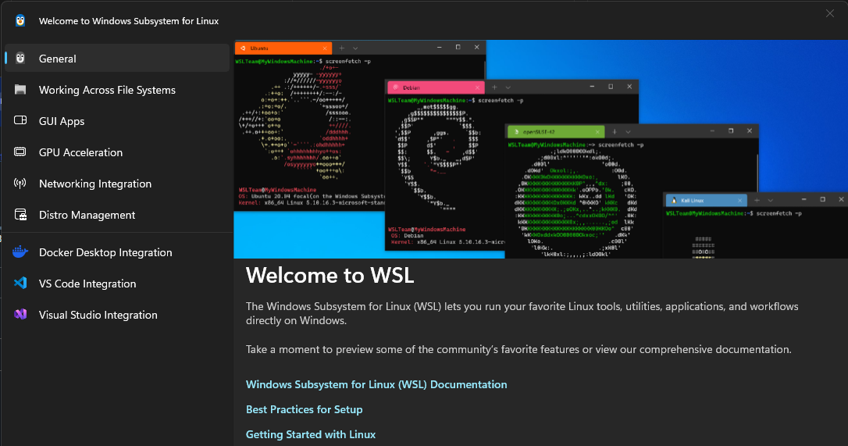

First Container running successfully
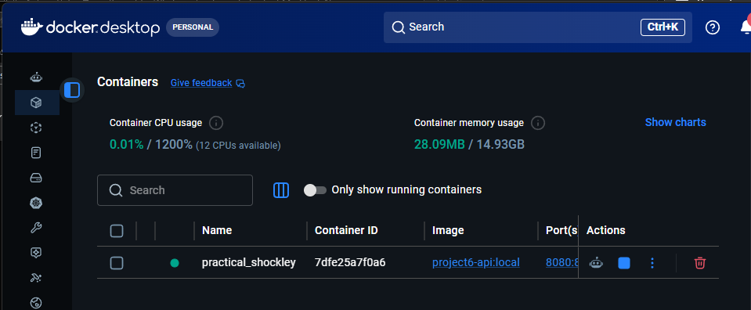

Container Logs in Docker Desktop
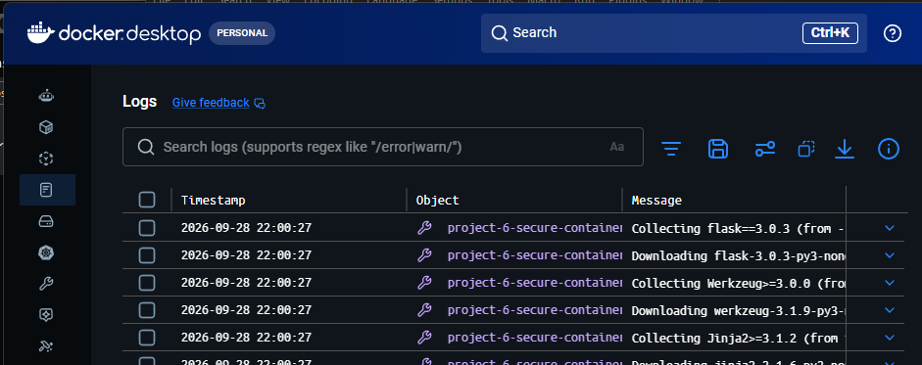

Container Image in Docker Desktop
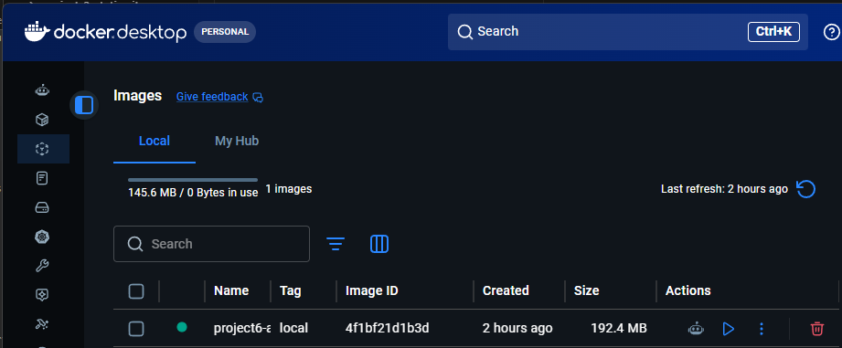

Repo created in Elastic Container Registry (ECR)
